The graph shows the count of energy usage (kitchen)in joules (J) across power factors. The power factor ranges from 0.7 to 1.0 on the x-axis, and the y-axis shows the count of readings. The data peaks around a power factor of 0.85.

This chart visualizes the count of energy usage (laundry room) in joules (J) by power factor. The x-axis ranges from 0.7 to 1.0, and the y-axis represents the count of Sub_metering_2 readings. It displays higher counts compared to Sub_metering_3, with a peak around a power factor of 0.9.

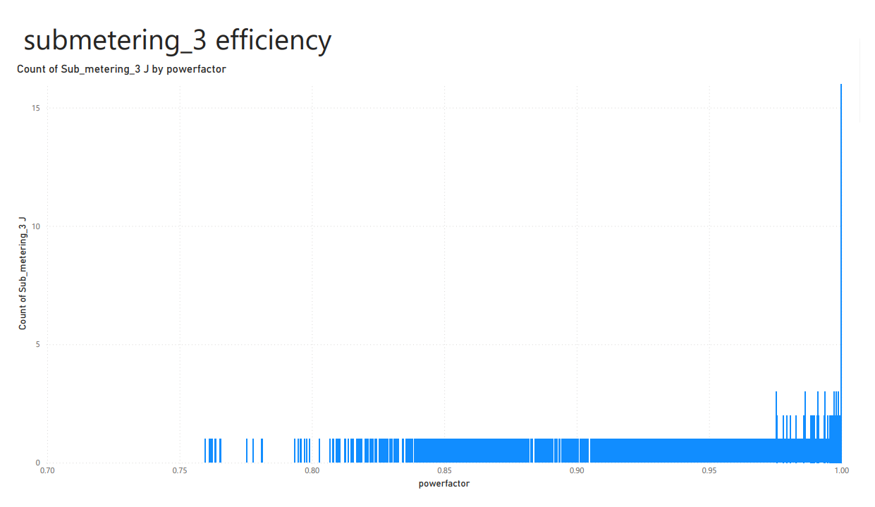

The graph shows the count of energy usage (water_heater and AC) measured in joules (J) across various power factors. The x-axis represents the power factor (ranging from 0.7 to 1.0), and the y-axis shows the count of Sub_metering_3 readings. The count peaks around a power factor of 0.85.

This line chart tracks the total apparent power (measured in thousands of joules) over a 24-hour period. The x-axis shows the time of day, ranging from 12:00 AM to 9:00 PM, and the y-axis represents the sum of apparent power. The power usage shows fluctuations throughout the day, peaking in the late morning and mid-afternoon.